Creating my first open source project named open_source_project1 with a readme.md file containing brief description

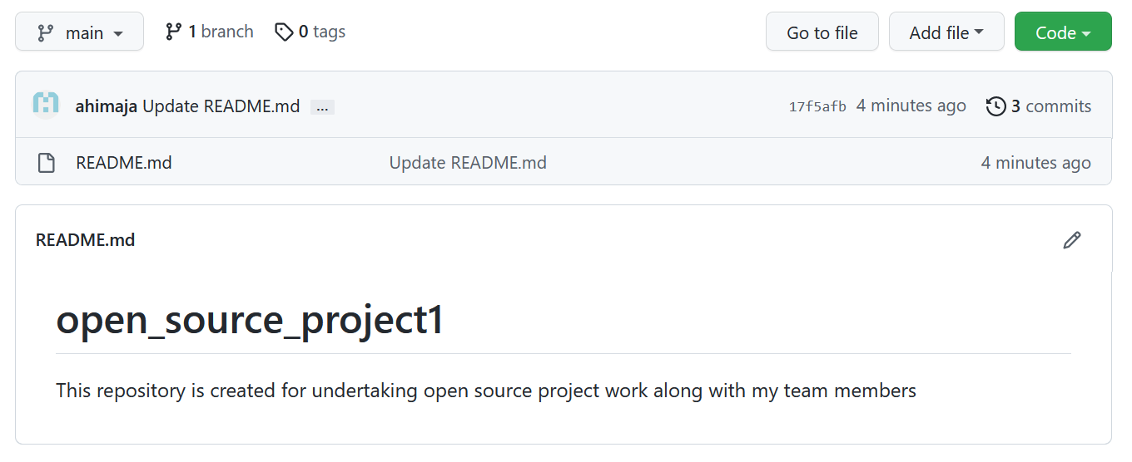

Invited 2 collaborators

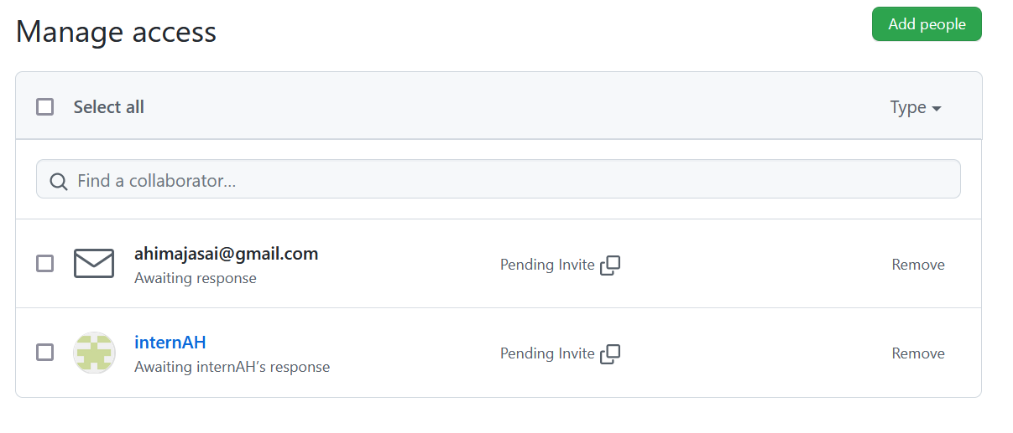

Made appropriate settings to git hub page in settings

